A hospital ward consists of a number of rooms each of which consist of a number of beds. Some beds are occupied by patients who are looked after by nurses and doctors. Patients have a number of activities scheduled for them, each of which is assigned to a nurse or doctor.

Activities can either be one-off activities or recurring activities; they can also be categorised into drug administration activities, clinical activities and observation activities.Activities are initially 'inactive' and become 'active' at a given time prior to their scheduled date/time. Active activities can be 'completed'; both 'active' and 'inactive' activities can be 'cancelled'. Patients are either 'awaiting care' or 'resting'; patients are 'awaiting care' whenever there are any 'active' activity associated with them.

Class UML Model

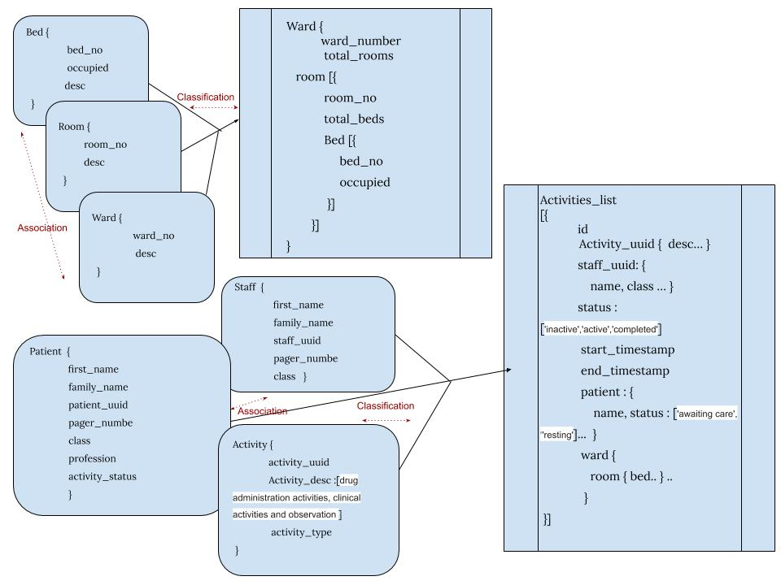

Activity Diagram

This is activity user flow where patient book appointment or admit and create the activity and its start the schedule time and assign to staff members. After schedule over or conditional activity can be complete and canceled.

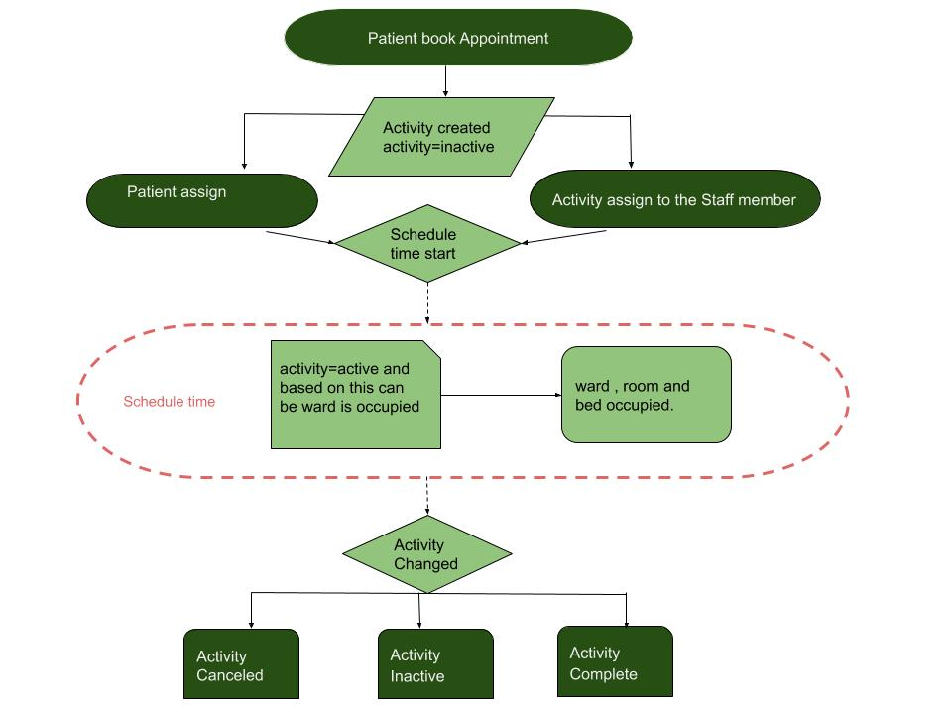

State Diagrams

This is the activity state machine diagram

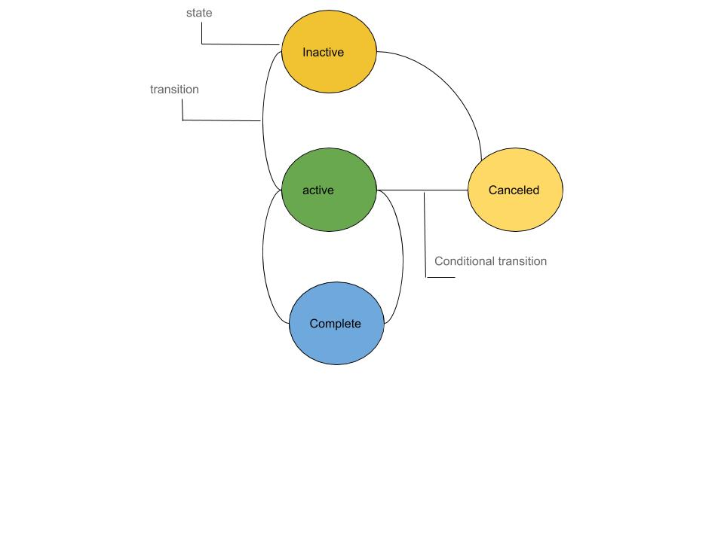

State Diagrams

This is the pat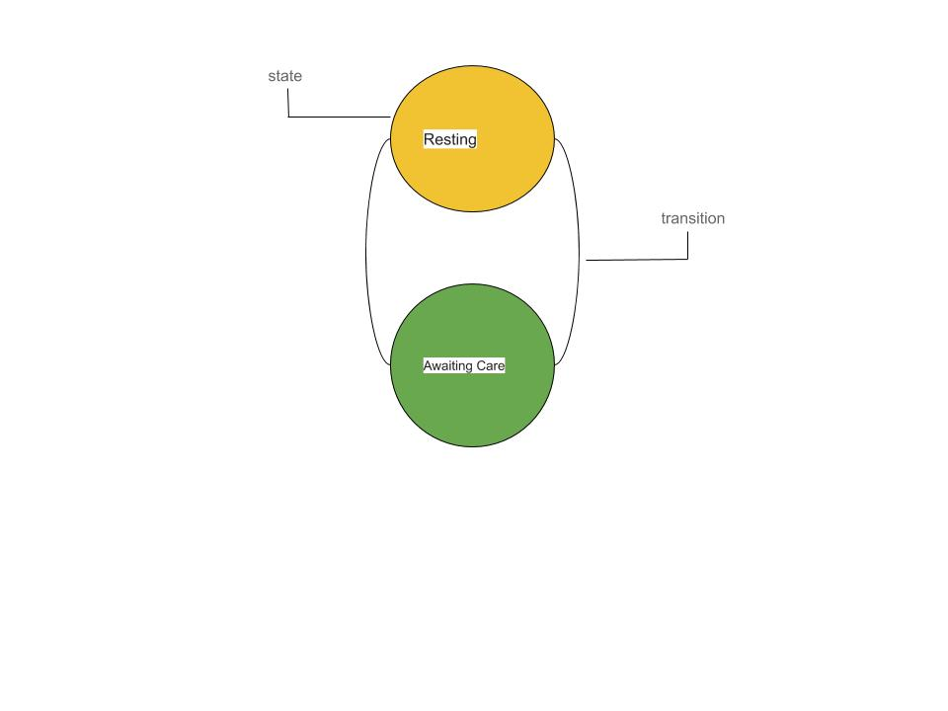ient status state machine diagram

Notes Or Assumptions :

1. There is master list of activities.
2. There is conditional way to cancel/end the active activity.
3. Assume default value the activity is “inactive” and default value is ward/room/bed are “unoccupied” and patient are “resting”.